BRAND DREAM1

Step-1 landing page

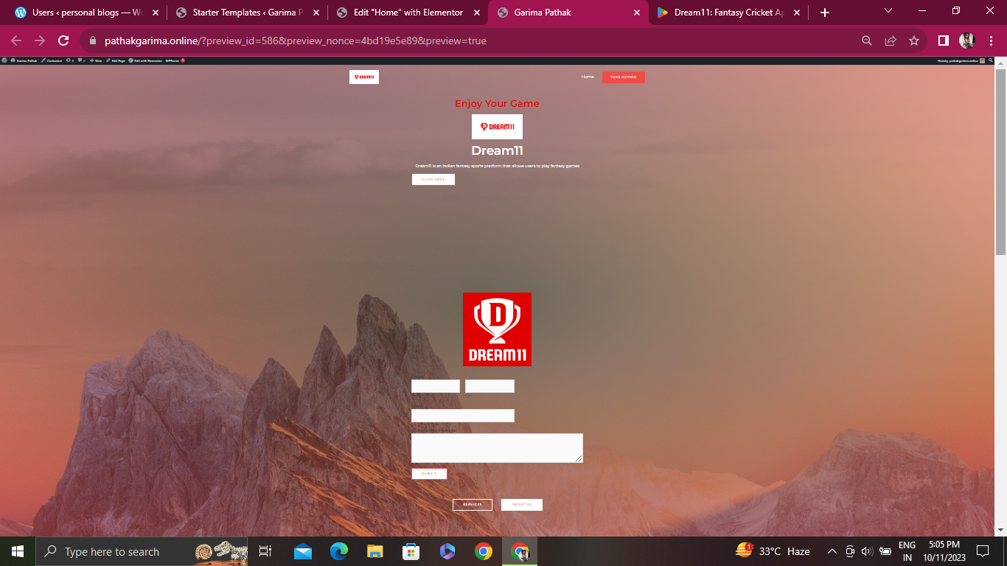

Step-2 Dream11's target audience includes sports enthusiasts primarily aged 18-35, both male and female, located in cricket-loving nations like India. Their users are generally interested in fantasy sports, cricket, and other popular sports leagues

Step-3 Competitors of Dream11 include platforms like MyTeam11 and FanDuel. Dream11's strengths lie in its early market entry, a wide variety of sports offerings, and a large user base. However, weaknesses may include occasional controversies related to legality in certain regions and the need for constant innovation to stay ahead in a competitive market

https://pathakgarima.online